**University of engineering & technology Peshawar**

****

**Digital Logic & computer Design-lab**

**Lab report #2**

**Spring**

**Submitted by: Maaz Habib**

**Section: C**

**Reg No: 20PWCSE1952**

**Semester: 3rd**

**“On my honor, as a student of University of Engineering and Technology Peshawar, I have neither given nor received unauthorized assistance on this academic work”**

**Submitted to:**

**Eng: faiz ullah**

**Department Of Computer System Engineering**

**Study of Basic Gates**

**Aims:**

* To study the basics gates.

**Apparatus:**

* Power Supply
* Breadboard
* Connecting Wires

**COMPONENTS:**

**ICs:**

* 7400
* 7402
* 7404
* 7408
* 7432
* 7486
* DIP Switch
* LEDs

**Theory:**

* **Logic gates** are the basic building blocks of any digital system. It is having one or more than one input, only one output. The relationship between the input and the output is based on certain **logic**.

Some logic gates are as following:

* **AND, OR, NOT, NAND, NOR, EX-OR.**
* It will only have two values one and zero.
* All digital circuits are switching circuits, they use high-speed transistors to represent either an ON condition or an OFF condition.
* The key requirement within each family is compatibility; that is, there must be consistency within the logic levels and power supplies of various integrated circuits made by different manufacturers.
* The experiments in this lab use primarily transistor-transistor logic, or TTL. The detailed performance characteristics of TTL depend on the particular subfamily.

**PROCEDURE:**

* Give biasing to the IC and do necessary connections.
* Give various combinations of inputs and note down the output with help of LED for all gates one by one.
* Observe the output and verify the truth tables for all gates.

**Real circuit image:**

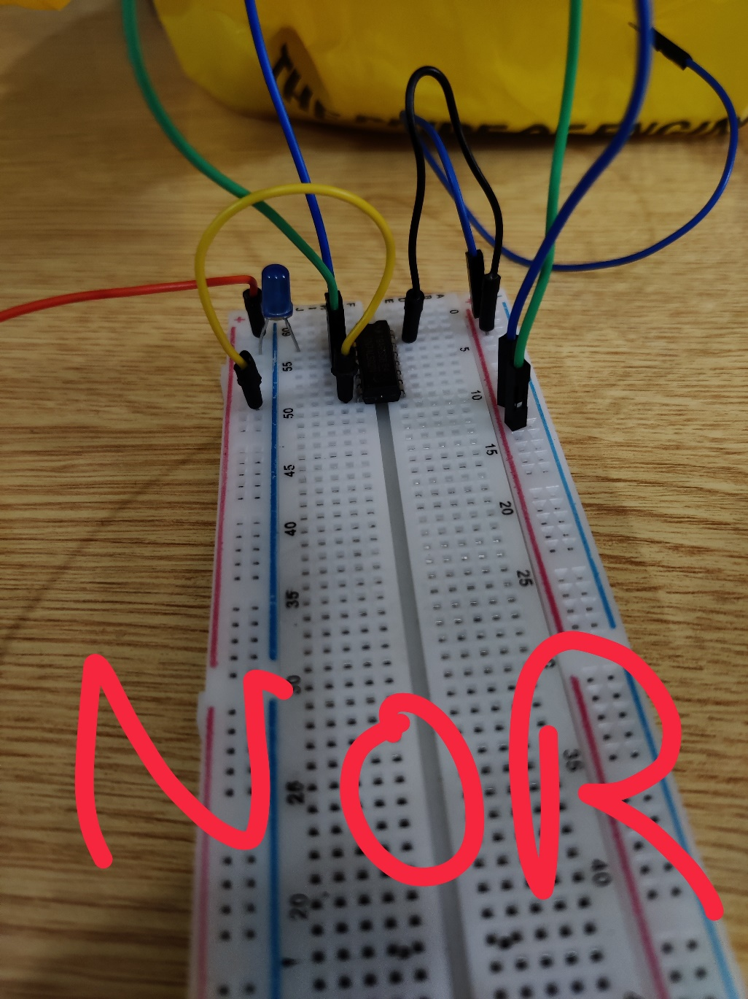

## AND Gate:

A circuit which performs an AND operation is shown in figure. It has “n” input (n >= 2) and one output.

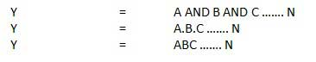

**Logic diagram:**

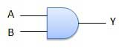

**Circuit diagram of IC 7408 (AND Gate):**

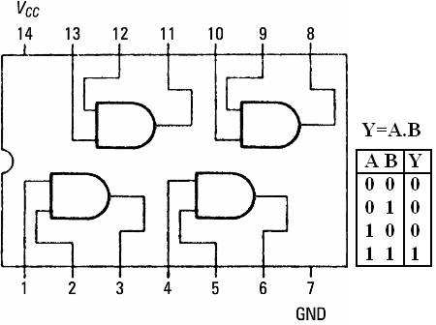

**Truth table:**

|  |  |  |  |  |  |
| --- | --- | --- | --- | --- | --- |
| AND gate | | | | | |
| Inputs | | |  | | **output** |
| A |  | **B** | |  | **Y=A.B** |
| 0 |  | **0** | |  | **0** |
| 1 |  | **0** | |  | **0** |
| 0 |  | **1** | |  | **0** |
| 1 |  | **1** | |  | **1** |

## OR Gate:

A circuit which performs an OR operation is shown in figure. It has n input (n >= 2) and one output.

C:\Users\AshfaqAhmad\Downloads\or1.jpg

**Logic diagram:**

C:\Users\AshfaqAhmad\Downloads\or_logic.jpg

**Circuit diagram of IC 7432 (OR Gate):**

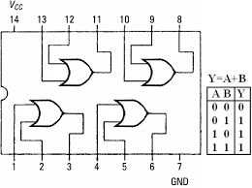

**Truth table:**

|  |  |  |  |  |  |
| --- | --- | --- | --- | --- | --- |
| OR gate | | | | | |
| Inputs | | |  | | **output** |
| A |  | **B** | |  | **Y=A+B** |
| 0 |  | **0** | |  | **0** |
| 1 |  | **0** | |  | **1** |
| 0 |  | **1** | |  | **1** |
| 1 |  | **1** | |  | **1** |

1. **NOT Gate**

NOT gate is also known as **Inverter**. It has one input A and one output Y.

NOT gate

**Logic diagram**

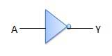

**Circuit diagram of IC 7404 (NOT Gate):**

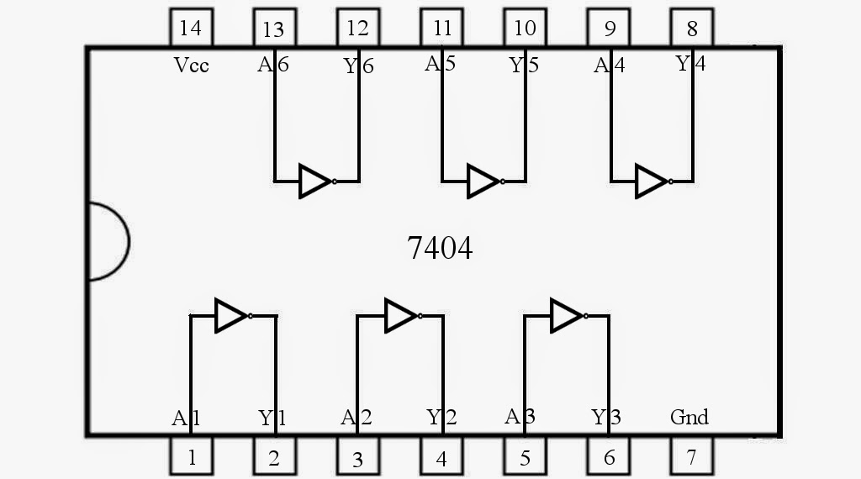

**Truth table:**

|  |  |  |  |
| --- | --- | --- | --- |
| NOT gate | | | |
| Inputs | | **Output** | |
| A |  | **Y=A’** |  | |
| 0 |  | **1** |  | |
| 1 |  | **0** |  | |

1. **NOR Gate:**

A NOT-OR operation is known as NOR operation. It has n input (n >= 2) and one output.

NOR gate

**Logic diagram:**

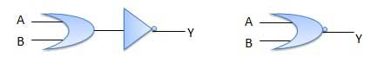

**Circuit diagram of IC 7402 (NOR Gate):**

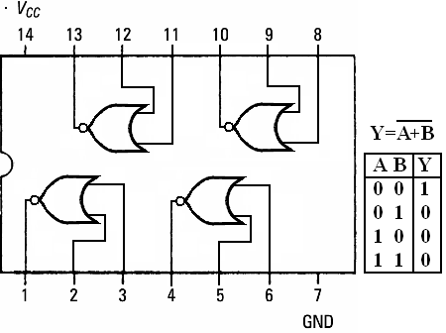

**Truth table:**

|  |  |  |  |  |  |
| --- | --- | --- | --- | --- | --- |
| NOR gate | | | | | |
| Inputs | | |  | | **output** |
| A |  | **B** | |  | **Y=(A+B)’** |
| 0 |  | **0** | |  | **1** |
| 1 |  | **0** | |  | **0** |
| 0 |  | **1** | |  | **0** |
| 1 |  | **1** | |  | **0** |

1. **NAND Gate**

A NOT-AND operation is known as NAND operation. It has n input (n >= 2) and one output.

NAND gate

**Logic diagram**

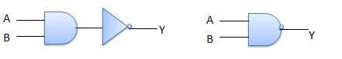

**Circuit diagram of IC 7400 (NAND Gate):**

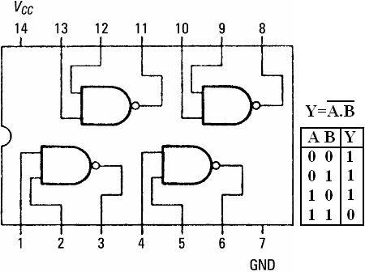

**Truth table:**

|  |  |  |  |  |  |
| --- | --- | --- | --- | --- | --- |
| NAND gate | | | | | |
| Inputs | | |  | | **output** |
| A |  | **B** | |  | **Y=(A.B)’** |
| 0 |  | **0** | |  | **1** |
| 1 |  | **0** | |  | **1** |
| 0 |  | **1** | |  | **1** |
| 1 |  | **1** | |  | **0** |

1. **XOR Gate:**

XOR or Ex-OR gate is a special type of gate. It can be used in the half adder, full adder and subtractor. The exclusive-OR gate is abbreviated as EX-OR gate or sometime as X-OR gate. It has n input (n >= 2) and one output.

Note that, if the inputs are identical the output will be zero. If the inputs are different the output will be 1.

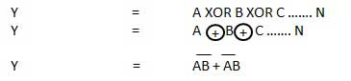

**Logic diagram**

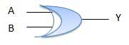

**Circuit diagram of IC 7486 (XOR Gate):**

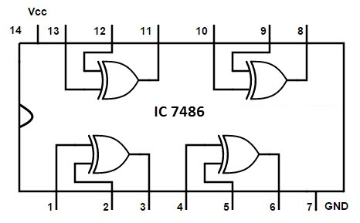

**Truth table:**

|  |  |  |  |  |  |
| --- | --- | --- | --- | --- | --- |
| XOR,EX-OR gate | | | | | |
| Inputs | | |  | | **output** |
| A |  | **B** | |  | **Y=(A.B’)+(A’.B) or Y=(A+B).(A’+B’)** |
| 0 |  | **0** | |  | **0** |
| 1 |  | **0** | |  | **1** |
| 0 |  | **1** | |  | **1** |
| 1 |  | **1** | |  | **0** |

1. **XNOR Gate**

XNOR gate is a special type of gate. It can be used in the half adder, full adder and subtractor. The exclusive-NOR gate is abbreviated as EX-NOR gate or sometime as X-NOR gate. It has n input (n >= 2) and one output.

Note that, if the inputs are identical the output will be one. If the inputs are different the output will be zero.

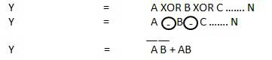

**Logic diagram**

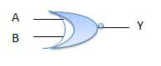

**Circuit diagram of IC 74266(XNOR Gate):**

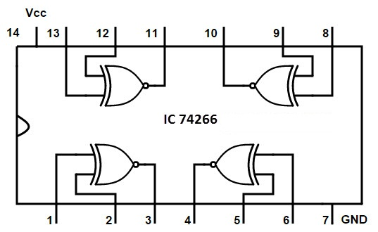

**Truth table:**

|  |  |  |  |  |  |
| --- | --- | --- | --- | --- | --- |
| XNOR,EX-NOR gate | | | | | |
| Inputs | | |  | | **output** |
| A |  | **B** | |  | **Y=(A.B)+(A’.B’) or Y=(A+B’).(A’+B)** |
| 0 |  | **0** | |  | **1** |
| 1 |  | **0** | |  | **0** |
| 0 |  | **1** | |  | **0** |
| 1 |  | **1** | |  | **1** |

**Answer 1:** A four inputs OR gate is required for this logic. We know that when any one of the inputs (in case of OR gate) is high the output will be high. Any open door will provide a HIGH input to the OR gate.

**Answer 2:** If more than two input AND gates are available, then we will connect its inputs by the following manner so that they work as two inputs;

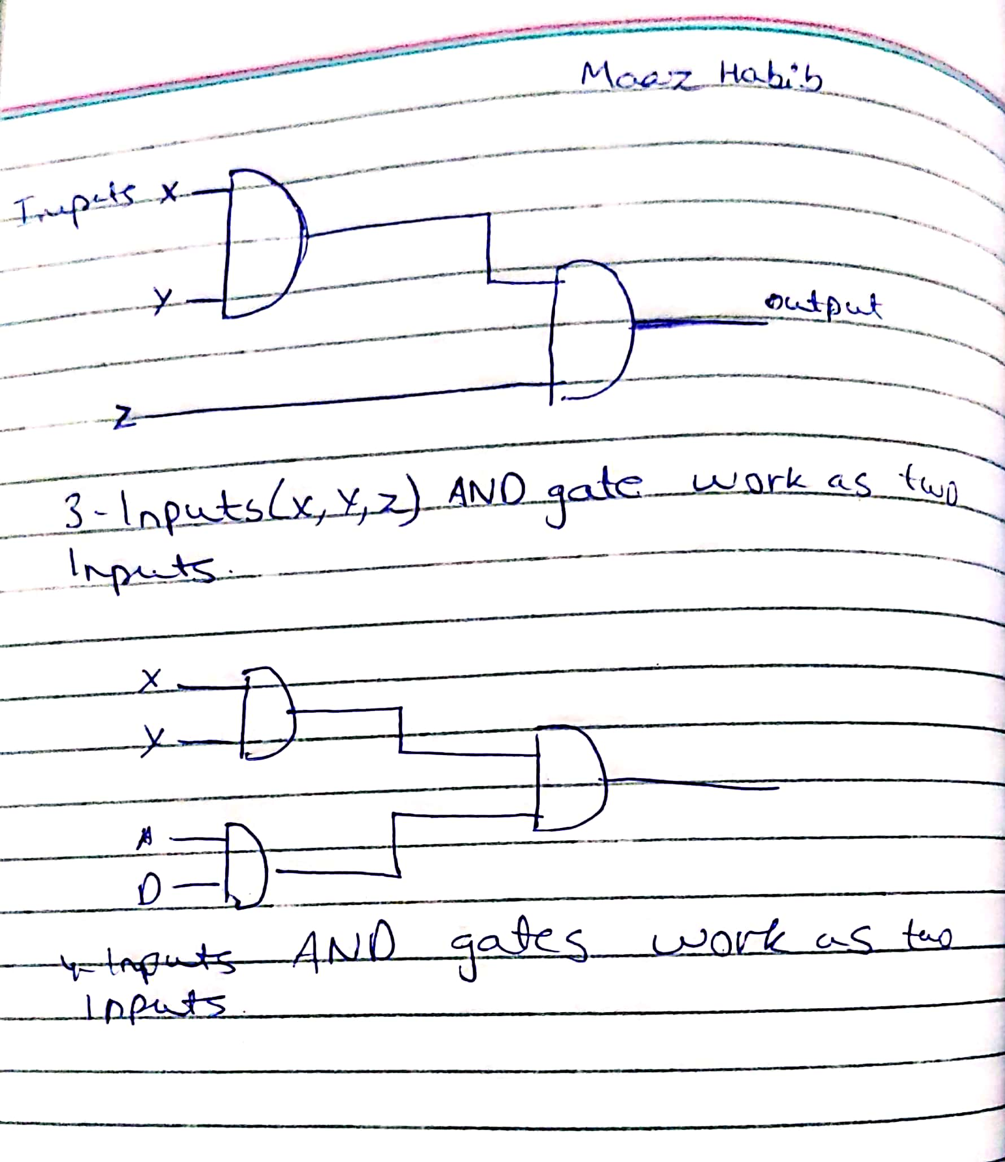

* Similarly, if more than two input OR gates are available, then we will connect its inputs by the following manner so that they work as two inputs.

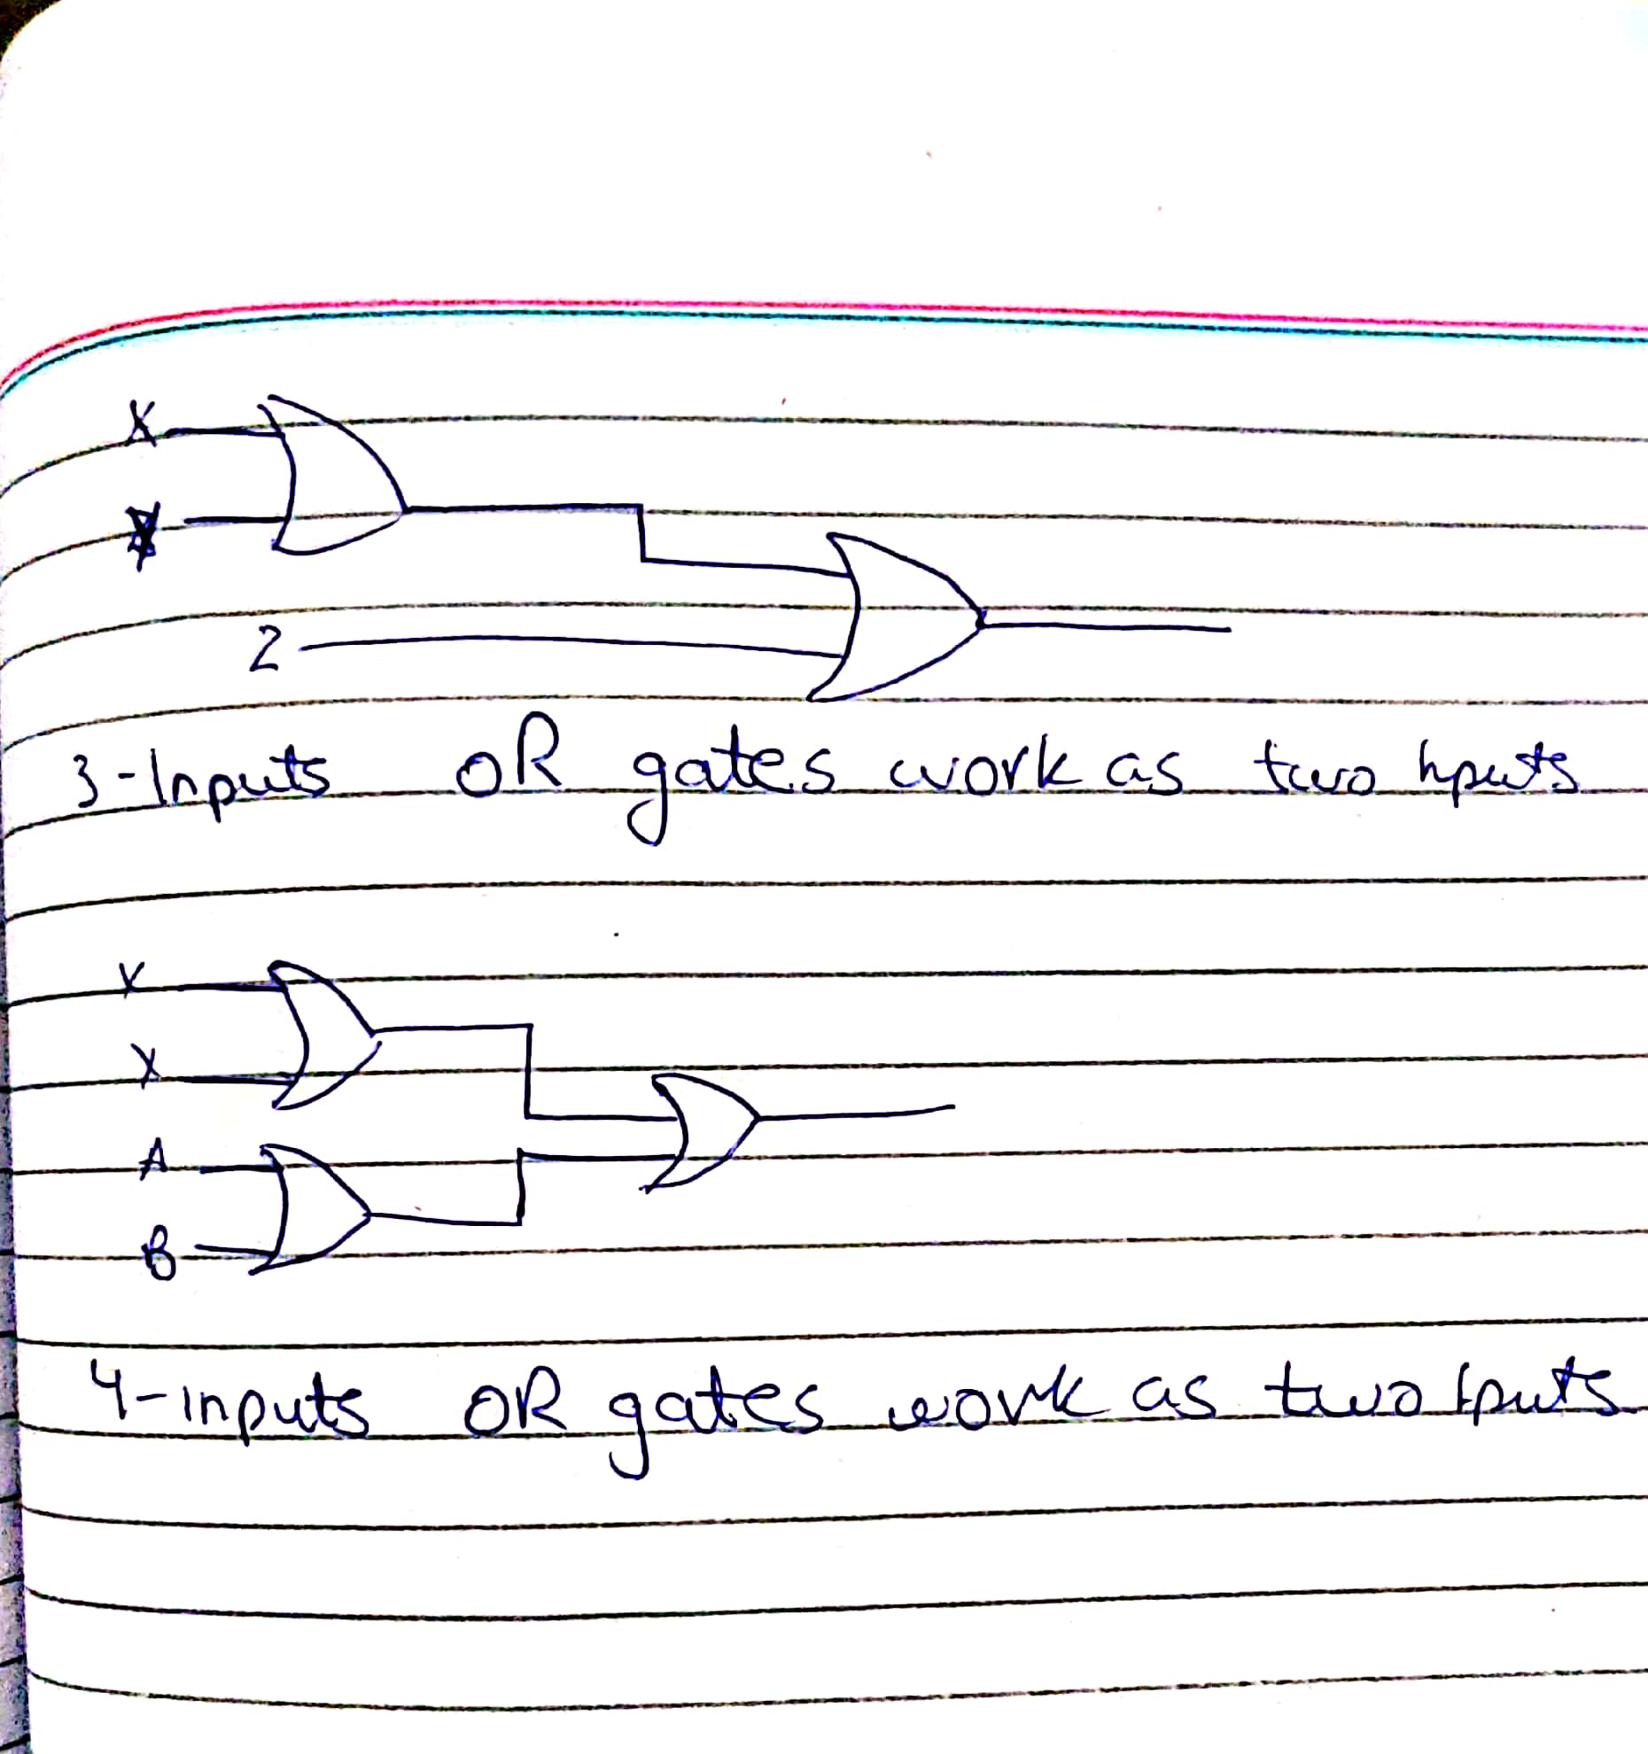

**THE END**